Town Car Intake Manifold Removal and Heater Pipe Replacement
1996 shown, others similar

Tools needed:
- A complete set of sockets, including a universal joint (You will be using an 8mm and 10mm socket for most of this procedure-have both normal and deepwell in both sizes)
- 4 inch and 10 inch extension for the drive you are using (I used 1/4” and 3/8” drives)
- A set of open-end wrenches (13mm will be needed, and you may find some of the bolts and nuts easier to get with an open-end instead of a socket)
- Torque wrench
- Crescent wrench that will open to 1-1/4 inch
- Spark plug wire removal tool (Optional)
- Putty knife or similar to clean the manifold mounting surface (A Dremel with a brass wire wheel makes this really easy)
- PB-Blaster
- A roll of paper towels (I used an entire roll)

Parts needed:
- Heater Pipe (Ford part number F1AZ-18B402-AF)
- 16 O-rings for the fuel injectors (Optional, but this is a good time to do these)
- Intake manifold gaskets (You will get two manifold gaskets and one throttle body gasket-This article does not cover removing the throttle body)
- New thermostat and O-ring

Terminology:
EGR = Exhaust gas recirculation valve
DPFE = Differential pressure feedback EGR sensor
TPS = Throttle position sensor
IAC = Idle air control
ECT = Engine coolant temperature sensor
EVAP = EVAPorative (emissions control)

You will be removing a lot of vacuum lines and electrical connectors. Use some method to keep track of where they go. I took digital pictures and labeled some lines with a sharpie. You will also have a pile of nuts and bolts. Label these as well.

Safety First!
This entire procedure is done from the top of the engine, both on the driver’s side and the passenger’s side. You will also have to lie across the engine to reach the heater pipe studs. The car should not be started for at least 8 hours, so that the fuel rail is not pressurized and the engine is cool. Make sure you are parked on level ground and the parking brake is set.
Remove the negative battery cable.

Let’s get started
The first step is to remove the alternator. Use a 1/2” drive ratchet to relieve the serpentine belt tension and pop the belt from the alternator. The alternator has two bolts on the bottom, and a bracket on the top. The top bracket is the same one that holds the sparkplug wires. Pop the spark plug wires from the bracket and undo the three bracket bolts. Disconnect the 3 electrical connections, undo the bottom alternator bolts, and sit the alternator, bracket, and bolts on the ground out of the way.
Next, you need to remove the throttle body cover (if equipped). It is the piece that has 4.6 Liter on it. It is secured by one nut on the passenger’s side and two prongs on the driver’s side that go into the air supply tube.
Remove the EVAP canister purge valve it is mounted on the passenger side, in the following picture it is already removed (circled in orange). This device has an electrical connection and two vacuum connections. One of the vacuum connections goes along the passenger side valve cover and connects to several parts. Disconnect all of the other connections, and you can leave it connected to the control valve. Disconnect the other vacuum line by squeezing the connection so it will release. Then remove the component with the vacuum hose still attached.

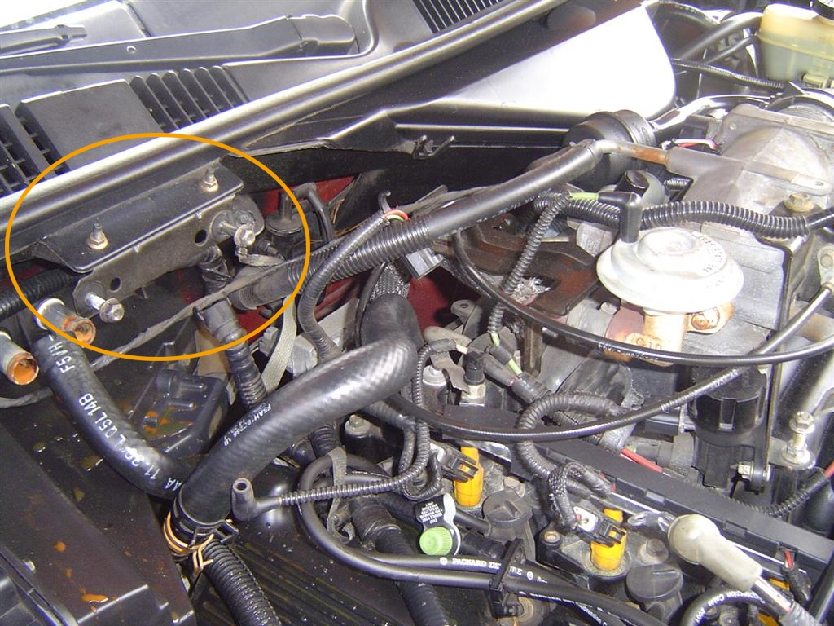

After that, you want to remove both throttle cables. First, remove the bottom one (the one with the grey plastic end). It pops up off of its pin. To remove the other one, rotate the throttle clockwise with your hand, like this:

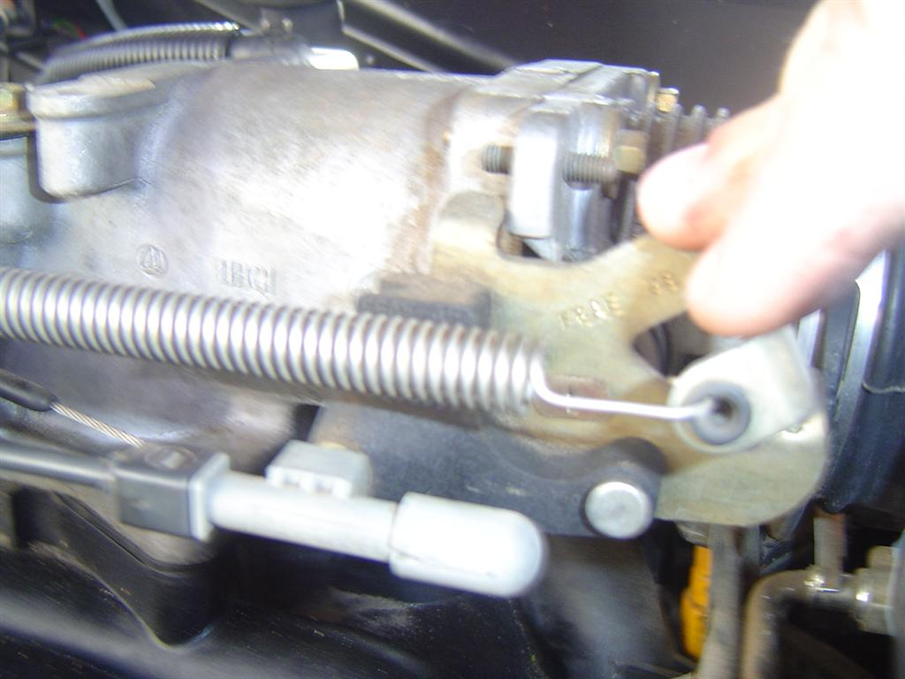

Then pull the cable down so it is at 6 o’clock. After that, the little pin will slide straight out toward the front of the car. Sit both cables off to the passenger’s side out of the way.
At the back of the engine, following the throttle cables around, you will find a black metal bracket. It is much easier to remove the EGR tube nut if you remove that bracket. It is secured by two 8mm screws. Unhook the throttle cables and sit the bracket next to the alternator.
Next, you need to remove the electrical connectors from the TPS and IAC. You will also be disconnecting both the crank case and IAC tubes from the air cleaner tube at this time. Look at the following picture.

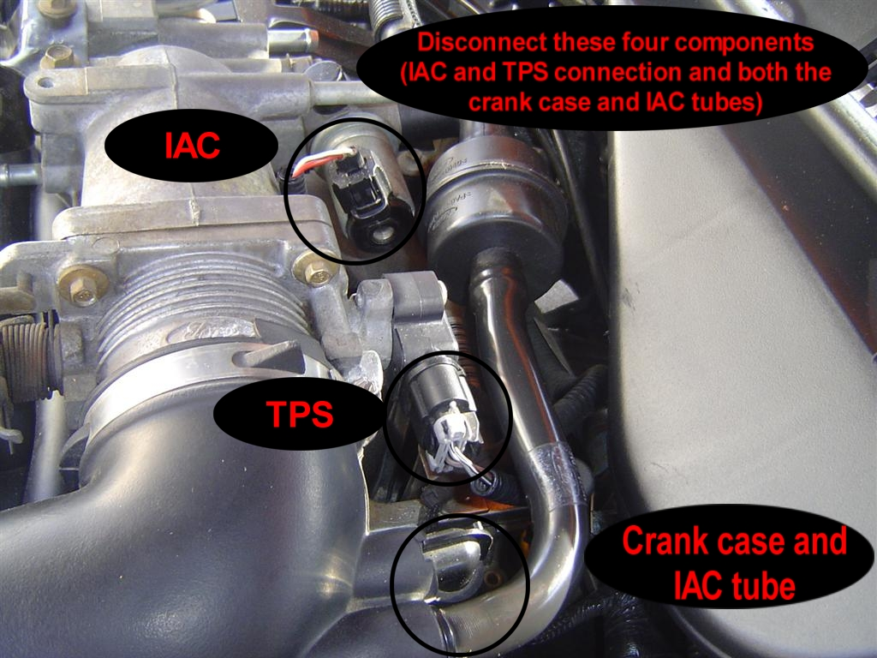

After that, move to the front of the engine and disconnect both ECT connectors, one on each side. One is grey, and the other is green. The passenger’s side ECT connector also has a ground connector going to the fuel rail stud. Disconnect that as well. Here is the grey one on the driver’s side, before the harness is disconnected.

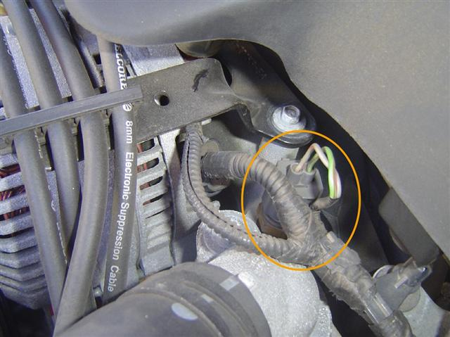

Now you are ready to remove the air cleaner tube. It is secured by a hose clamp on each end. Remove it and sit it on the ground.
Next, you need to remove the upper radiator hose. If you mind coolant running everywhere, drain the radiator. I only disconnected the end of the hose where it attaches to the manifold. Then I just bent it down toward the fan and left it alone. It is out of the way there. After that, you are ready to pull the 8 spark plug wires. You have to pull all of them, so unless you have a good memory, label them in some way so you know where they go. I used my sharpie. Also, you need to disconnect the 8 fuel injector connectors. These connectors are laid out in such a way that it is fairly obvious where they reconnect. I did not have to label these. Look:

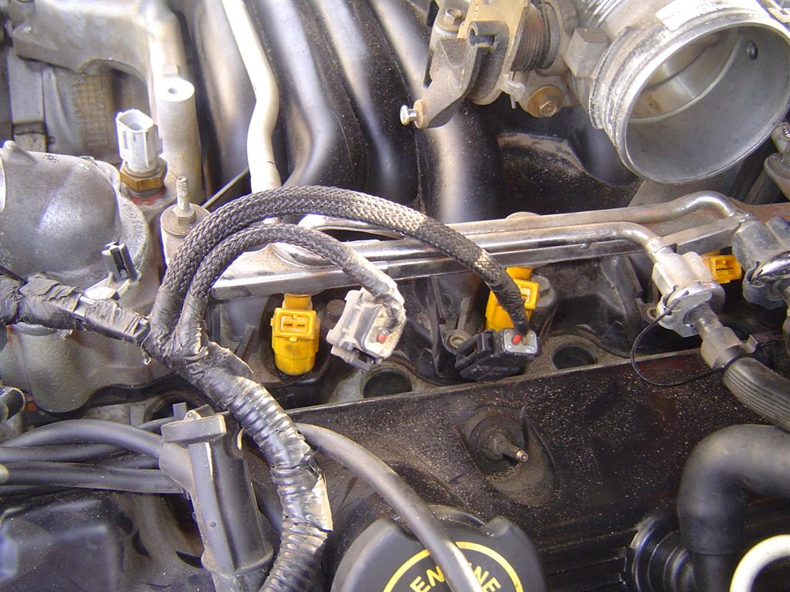

The wiring harness on the passenger’s side is snapped onto the fuel rail. Unsnap it and the entire harness can be flipped out of the way.
The EGR tube nut is next. It will be much easier to remove this nut if you remove the metal bracket that the throttle cables rest on. In fact, I could not get my crescent wrench on the nut at all until I removed that bracket. The EGR tube is not flexible, but you will be able to get the intake manifold off without removing it. You may need to shoot some PB Blaster on the nut so it will release. In the following picture you can see the EGR nut and the throttle cable bracket that is partially concealing it.

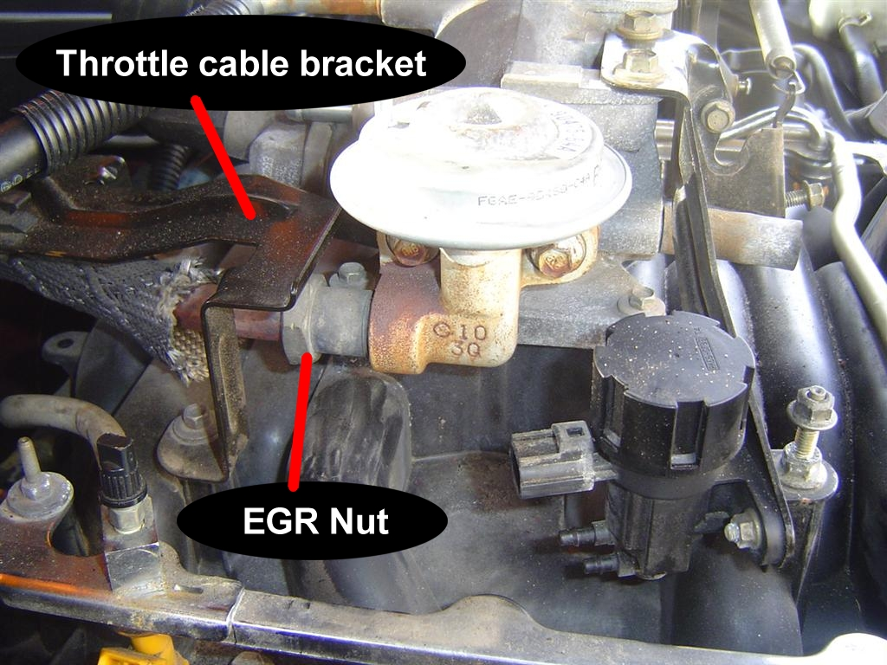

Next is the fuel rail. The rail is normally pressurized, but if the car has sat for 8 hours, most of the pressure will bleed off. I did not have a problem with the fuel pressure after my car sat overnight. You have two options with the rail. The first is to obtain a spring lock coupling disconnect tool for 3/8 and 1/2 inch line. The other option is to leave the fuel lines connected to the rail and just maneuver the entire rail around as needed. I chose the second option, so I will write the rest of this article using that method.
First, you should try to remove as much dirt and grim from the fuel injector area as possible. The rail is attached with four 8mm studs. Remove all four studs. The rail will now be free, only held in place by the fuel injectors. Working on the passenger side front injector first pull up on the rail. The injector should pop out of the manifold and stay in the rail. Be prepared for fuel to spill however. If the injector pops out of the rail, you will lose whatever fuel is in the rail. It won’t be much though. After you have worked all 8 injectors lose, you can pull the injectors from the rail and replace all 16 fuel injector o-rings. You will lose fuel when you pop the injectors out, so have a small plastic cup available to catch it.
The two hoses that connect the driver and passenger side rails are somewhat flexible. We will be depending on that flexibility to maneuver the fuel rail around the throttle bottle.
Remove the thermostat housing and the heater hose from the manifold. Now you are ready to remove the manifold. There are nine bolts, which will require your 10 mm socket and extension. The five on the passenger side are straight forward. The driver’s side bolts will require a universal joint. The rear bolt is a bit harder to get to, but it is possible.
Now the manifold can be lifted off and removed. You will want to double check that you have all electrical connections and vacuum lines disconnected. While removing the intake, you will need to also maneuver the fuel rail assembly around. The fuel rail will be able to clear the throttle body with only minor difficulties. After the manifold is out of the way, you can rest the fuel rail on the EGR tube, which will be sticking out over the block.
Congratulations! The hard part is done, and this is what you will have:

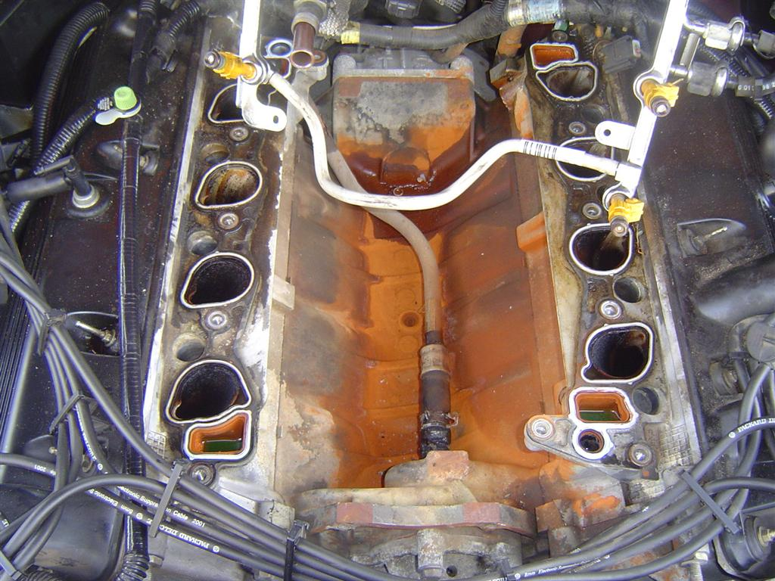

STUFF ALL EIGHT INTAKE PORTS WITH PAPER TOWELS BEFORE PROCEEDING!
Now, we will replace the heater pipe. It is prone to failure. Disconnect the spring clip on the rubber hose front connection. Carefully remove the rubber hose from the water pump spout. If you have not drained the radiator, the coolant will spill onto the top of the block. It won’t hurt anything though. That spout is another potential leak, and you do not want to damage it. Replacing it is not covered in this article. The other end of the heater pipe is attached by two studs.
To get to those, you need to remove the DPFE mounting plate. You may have to remove the second heater hose from the heater pipe to get to the nuts holding the DPFE plate on. The lower spring clamp on the heater hose is in a tight spot. I tried needle nose pliers and a lot of yanking, and eventually I pulled the hose from the heater pipe. I threw that spring clamp away and replaced it with a normal hose clamp.
This is the DPFE, before the intake has been removed. You can also see the grounding wire. I have disconnected the grounding wire in this picture, but it was originally connected to the top DPFE stud. Note that I already have both heater hoses removed, before I took off the intake manifold.

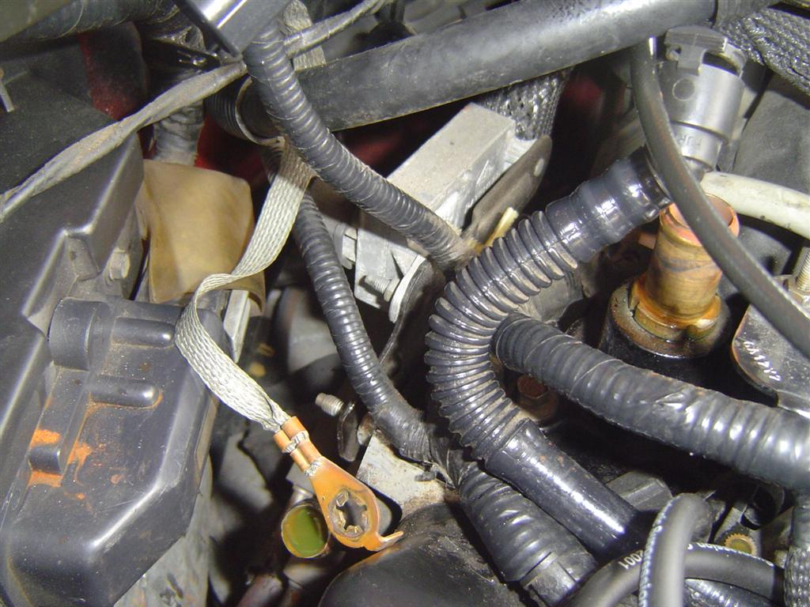

Both studs are 13mm, and you will probably need your open end wrench for these. I was able to get the top easily. For the bottom nut, I had to lie across the passenger side of the engine. Be careful not to break anything (On you OR the car!). You may have better luck from the driver’s side.
Once you have both studs out, the heater pipe can be easily removed towards the front of the car. You will have to wiggle it around a bit, but it will slide right out. Slide the new heater pipe in the same way, and reconnect the studs and the rubber hose end. Remove both manifold gaskets and clean the mounting surfaces. It is very important that the mounting surfaces be very clean. I used a Dremel with a brass wire wheel on the block, and used paper towels on the intake manifold. The plastic intake should not be as hard to clean as the block. When installing your new intake manifold gaskets, make sure the mounting prongs are down, locking the gasket to the block.
When reinstalling the manifold, install the bolts in the order shown in the following picture. After installing the intake fill the block through the thermostat opening with coolant, and install your new thermostat and O-ring. Then install the thermostat housing. Don’t forget to remove the paper towels from the intake ports. All bolts are tightened to 18 ft-lbs.

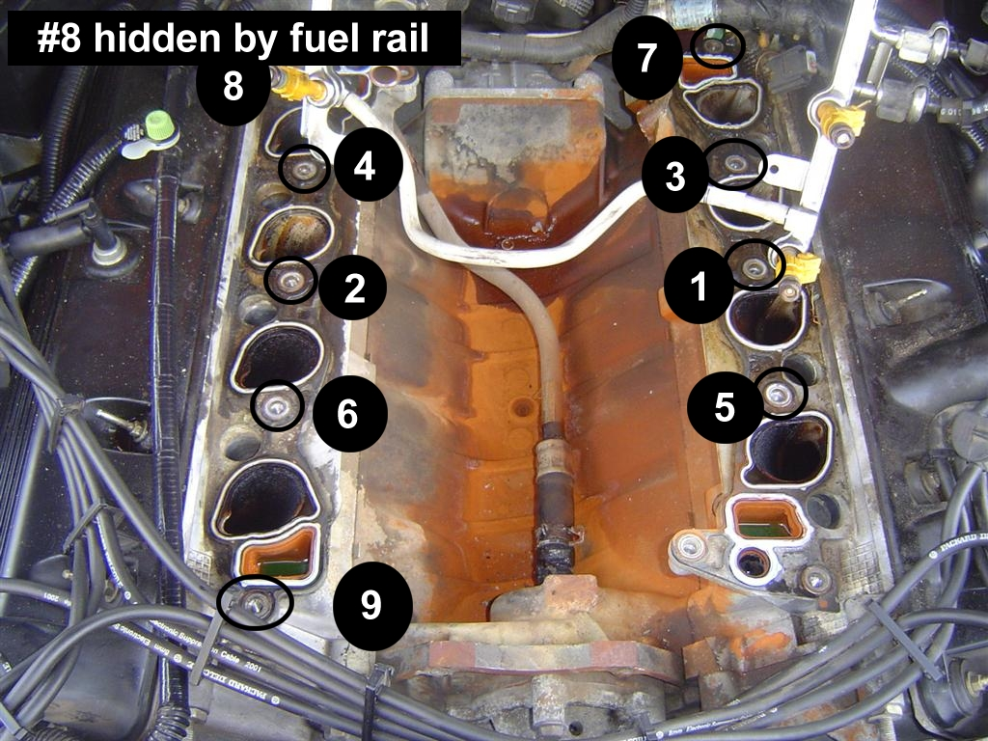

When installing the intake, you will need to make sure the EGR tube aligns with the EGR valve. Additionally, you will need to feed the fuel rail over the throttle body. Make sure the back of the fuel rail is under the EGR tube when you start to position the manifold. Also, make sure none of the wiring harnesses or throttle cables fell down on top of the transmission.
The remainder of the reinstallation is the same as removal. I would recommend you replace all of the spring hose clamps on the heater hoses with regular hose clamps
If you spilled any fuel on the engine while working with the fuel rail, let the car sit for several hours before hooking up the battery so the fuel has time to evaporate.

You are done!

